**Hotel Management System Overhaul**



***Use Case Summary Document***

**Version No. 3**

**Project Document Revision History**

|  |  |  |  |
| --- | --- | --- | --- |
| **VersionNumber** | **Date** | **Revision Author** | **Description of Revision** |
| 1 | 6/11/20 | Jeffrey Fishman, Monier Abdullah, Khalid Saeed, Peter Schubert | Initial version of use case summary |
| 2 | 6/21/20 | Jeffrey Fishman, Monier Abdullah, Khalid Saeed, Peter Schubert | Revision of Initial version of use case summary to include a better use cases |
| 3 | 7/3/20 | Jeffrey Fishman, Monier Abdullah, Khalid Saeed, Peter Schubert | Addition of flows obtain from discussions with Steiner |

|  |
| --- |
| **Table of Contents** |

**Introduction** **3**

**Project/Application Actors** **4**

**Use Case List** **5**

**Use Case Diagram(s)** **6**

**Use Case Summary** **6**

**Use Case Summary Review and Signoff** **8**

# **Introduction**

This document captures BUSINESS requirements at a high level by identifying ALL the use cases in a project/application.

Write a few paragraphs describing the purpose of the project/application in the Introduction.

The purpose of the new hotel booking system is to replace the old and outdated hotel booking system. The old system is outdated, slow, inefficient and the employees have to put the customers on hold. The employees also have to work with multiple screens to pull up customer information about the reservation in order to cancel or rebook.

The new system will allow for a smooth experience for both the customers and employees. The new system will allow for outside bookings and allow the implementation of a reward system in which the customer will be able to view the types of redemptions for their points and be able to see if they will be able to upgrade

The customer will be able to create and login to their account to view hotels, book a room, view existing bookings, and view collected metrics.

The hotel booking system will allow employees to view bookings and metrics, manage the overall operations of the hotel, and be able to make changes to a customer’s reservation. The system will be used to check customer and hotel metrics such as customer’s login information, reservation preferences, hotel room availability, changes to reservations, reward points, and confirm bookings.

# **Project/Application Actors**

An actor is someone or something (e.g. application system) outside the system or business that interacts with the application. List the actors involved in ANY use case. Actors should be a person, system, or time.

|  |  |
| --- | --- |
| Actor Name | Description |
| Customer | Primary Actor: interacts with the system to login, book, modify, and cancel ~~stays~~ reservations, view and manage individual reward points, edit name and location. Also interacts with Employee to modify the reservation |
| Employee | Primary Actor: interacts with system to book, modify, and cancel, ~~and~~ review reservations, create accounts for customers, view summary reports and hotel informatics, and manage the hotel and other various functions |
| System Database | Secondary Actor: interacts with the system to store the necessary data about the customer, employees, hotel, and reservation. |
| Third Party Booking Website | Primary Actor: Interacts with the system to make requests for booking from third party websites to existing or new customers and create new users. |
| Hotel Management System | Interacts with the system to store, collect, or manipulate data within the system’s data stores and present back to the Customers and Employees |

# **Use Case List**

List ALL use cases identified for the project/application.

~~New Determined Use Cases~~

* Access Hotel System
* Reservation
* Check in/Check out
* Rewards
* Hotel Administration

# **Use Case Diagram(s)**

~~New Use Case Diagram (Ver. 2)~~

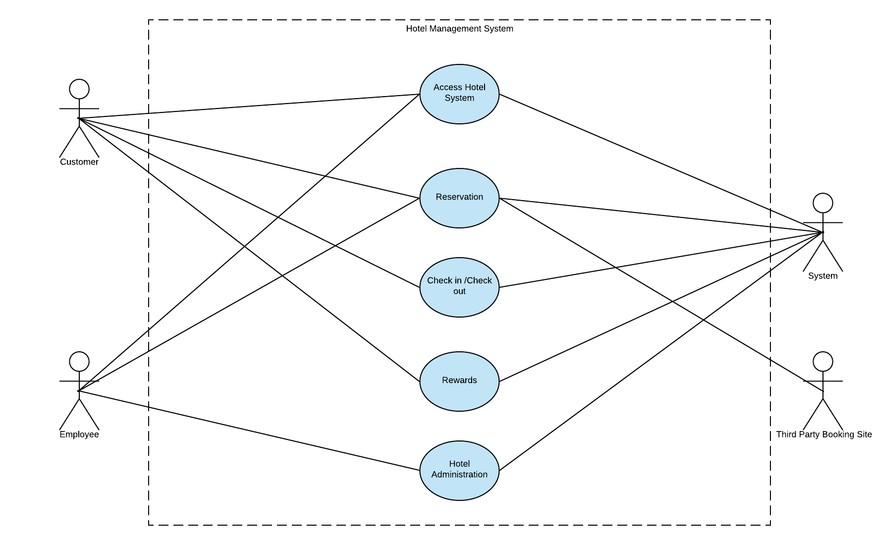

# **Use Case Summary**

# JF: **These should not include *steps*, that**’s part of a different document. These are just flows.

New Updated Use Case Summary

1. Access Hotel System - Khalid
   1. Create Account
   2. Modify Account
      1. View and edit their name and location (only customer information stored)
   3. Forgot user credentials
      1. Employee can look up user credentials of customers and Employee
   4. User Login/Logout
   5. Check User Login Information
   6. ~~View and edit their name and location (only customer information stored)~~
2. Reservation-Jeff
   1. View hotel and room overview
      1. Provide reservation dates and number of guests for accurate availability
      2. Room information (i.e. type and number of beds)
         1. Room type
         2. Room availability
         3. Quote for room price
         4. Number of guests / beds per room
   2. Create booking for a room to a customer and customer’s guests
      1. Check-in / check-out dates
      2. Upgrade room for a cost
         1. ‘Process Payment’ for cost difference
   3. Process Payment
      1. Customer selects payment options
         1. Credit Card
            1. Accumulates points
         2. Use Points
            1. If there’s still a balance, customer still needs to pay it before or at check-in
            2. Does not accumulate additional rewards
         3. Use a combination of Points and Credit Card
            1. Use points first, then card for remaining balance
      2. ~~On payment failure, ask for another card number or payment method~~
      3. Get reservation number ~~and assigned room number~~ after successful payment
      4. Update metrics for hotels, rooms, and revenue earned
   4. Modify a customer’s booking / guests ( Both Customer & Employee ~~Only~~)
      1. Modify booked room
         1. Update number of guests on booking up to the number of beds / guests allowed from the original reservation
         2. Upgrade or downgrade a particular customer’s room type
            1. Charge or refund for the corresponding amount and type of upgrade or downgrade
      2. Update booking dates at or past today’s date
   5. Third-party reservation requests
      1. Request for creation of a booking
         1. Can also create a user account, but not required
         2. Also request for upgrades and cancellation
      2. Respond to confirm or deny the reservation request
   6. Waitlist System
      1. If a particular room for a particular location is full, request to either upgrade, waitlist, or cancel reservation
         1. Same thing for third party, notify unavailable
      2. If room becomes available notify next person in queue
         1. After a certain amount of time if person doesn't respond dequeue
3. Check In/ Out - Monier
   1. Customer checks into their hotel reservation
      1. If reservation still has a balance, need to pay the remainder before check-in succeeds
         1. Reservation ‘Process Payment’
      2. Need name and reservation number for successful check-in
      3. Employee looks up reservation and checks in customer
   2. Customer checks out of their hotel reservation
      1. Name and reservation number
      2. Employee looks up reservation and checks customer out
4. Rewards - Monier
   1. Check customer rewards points
      1. History of points received per reservation
   2. Uses points to get discounts
      1. Check which discounts are available per amount of points
   3. Use points to add events and packages along with current reservation
5. Hotel Administration-Peter
   1. Employee has to be able to login via Access Hotel System
      1. Username and password
   2. Manage Hotel and Hotel locations
      1. Employee checks on the availability of and unavailability of rooms in a hotel
         1. Cannot change availability unless for maintenance after room becomes available
      2. Is able to set the cost (monetary and in points) of the rooms and maximum capacity per room
         1. Points per type of room
         2. Quantity of beds in each room
         3. Price Changes are logged
   3. Generate summary reports of hotel metrics for a given time period
      1. ~~Frequency/most visited customers~~
      2. ~~occupancy~~
         1. ~~The average number of occupied rooms per a given day~~
      3. ~~Popular hotel rooms~~
      4. ~~Total employee pay / expenses~~
      5. ~~Revenue of the reservations~~
      6. Past
         1. Revenue of past reservations
         2. Popular hotel rooms/Locations
         3. average number of occupied rooms per a given day
         4. Most visited customers
      7. Future
         1. Future revenue from reservations
         2. Popular hotel rooms/Locations
         3. average number of occupied rooms per a given day
         4. Most visited customers

# **Use Case Summary Review and Signoff**

|  |  |  |  |  |
| --- | --- | --- | --- | --- |
| Review and Signoff of the Use Case Summary | | | | |
| Name | Project Team Role | Signature | Date | |
| Peter Schubert | Team Lead /Software Developer | PS |  | |
| Monier Abdullah | Software Developer | MA |  | |
| Khalid Saeed | Software Developer | KS |  | |
| Jeffrey Fishman | Software Developer | JF |  | |